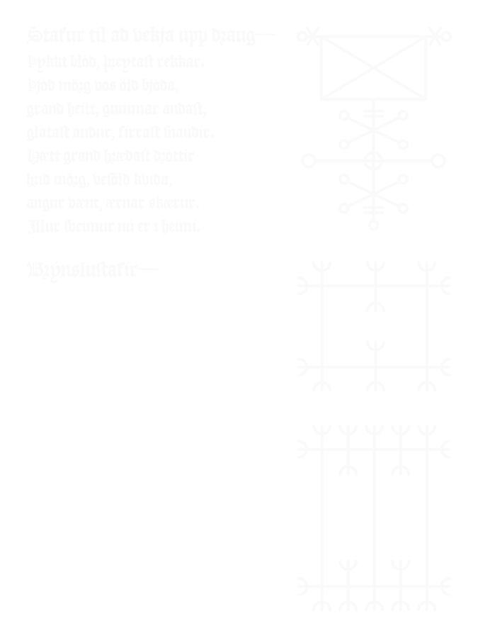***Blood Faith XIV***

To the High Council of Thirteen,

I write to give an account of my delay. After discovering that Porfirio had purloined the Relics from the *Ales Stenar*, I proceeded to the nearby port of Ystath, where I chartered a vessel to carry me to Danmark, intending to travel thence to Srath Chluaidh to retrieve our clairvoyant brother, Lailoken. However, an unexpected wind blew the ship off course and dashed it into a rocky archipelago roughly northeast of our point of embarkation. When the storm had subsided, I made my way inland that I might make my way to another port. Along the way I encountered a group of *Homo mortalis* scholars scrutinizing a stone embedded in the earth. I waited for them to depart and then examined the stone myself. Upon inquiring of the local population, I learned that they call the stone the Runamo and they believe that it was carved by Þórólfr.

I ascertained from the gathered scholars that this message has eluded interpretation since its discovery. Indeed, it was so cleverly disguised that I’m astonished that they identified it as a message in the first place. The inscription itself was written using the Ogham script (not fuþark, as I overheard one the scholars propose), but in the language of Old Church Slavonic—an idea probably acquired from ancient *ˁpr.w* in the Novus Mundus. The inscription yielded five cryptic words: “Extremest Eagle Little Wide Bent”.Upon investigation, I determined that this indicated an uninhabited islet, called Tindhólmur, in Føroyar. At this point I had no reason to believe further investigation would prove fruitful, but I was so intrigued that I temporarily (or so I thought, then) abandoned my pursuit of Porfirio and sailed to those remote islands.

I spend several months seeking answers in Sørvágur, but made little progress. Eventually I condescended to seek the help of a local Céile Dé, named Goraidh. He had taken an ordinary quartzite stone which had been rubbed smooth in some rivulet and inscribed it with a symbol he called a *valknut* (which I suspect is somehow tied to the Opposition, for it was somewhat repellant to me). Even though this sunstone (for so he named it) was his own creation, his faith in it was so great that he could cause it to project light which would point the way to whatever thing he should seek. (It would not do to let one of such powerful faith live, so once he’d served his purpose I destroyed him and cast his terrible stone into the sea.)

Before I ended his life, however, he guided me to a large, flat stone on Tindhólmur. The site was swarming with disgusting *Gräuel*, but my guide was oblivious to them. I suspect they understood (on some level we are not capable of because of the complete Shedding) that the powers of Revival were interred there. With great effort Goraidh and I removed the stone. Underneath was a stone box filled with miscellanea and guarded by a salamander. The salamander was repulsed by the sunstone and quickly abandoned its cache. Among the sundry items in this hidden box was an incunabulum filled with Nordic staves. Some of these staves, which I shall send to you, show great promise in helping to determine the proper configuration of the magic circles in order to Reclaim our Master.

I return to you with all haste, but I must still retrieve Lailoken from the Cassiterides. Thus to minimize delay, I intend to send to you the relevant pages of the incunabulum by way of a courier as soon as possible.

Your Servant,

Hæmming

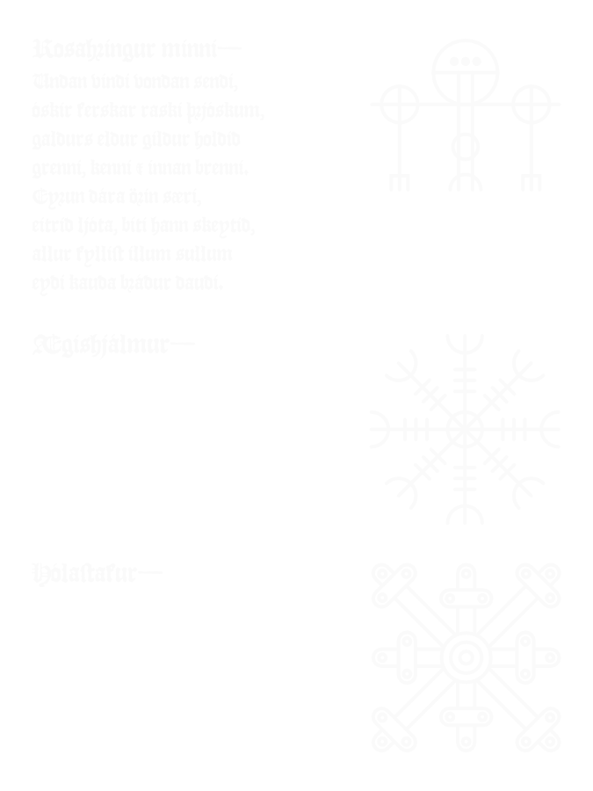

P. S. I regret to hear of the destruction of Gaius Messōrius Vēnātor as he was a useful tool and very adept at his chosen calling. He will be difficult to replace. However, I am in full accord with the decision of the Council—even though he did not believe what he’d read, it would not be wise to let anyone who knows such things to live.